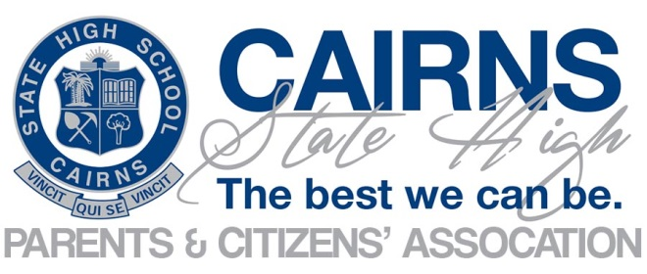
Minutes of General Meeting
Tuesday 17 October 2023
Meeting Commenced @ 1733
Apologies : Brendan Begley, Anthony Easton, Glen Burnett, Lauren Bruce
Attendees:
Chris Zilm  (Principal) | Jules Steer  (P&C President) | Carolyn Green  (P&C Secretary) | Marty Long | Clio Carney | Kate Coates
Karen Freilingsdorf | Jaimie Cornford | Jeff Bruce

Jules opened the meeting with the Acknowledgement of Country and introduced Mr Marty Long to present on the 2024 Cambodian Study Tour.
- Cambodian Study Tour
- Marty Long presented on the Cambodian Study tour scheduled from 30 November – 14 December 2024.
- The aim of the tour is for students to learn about Cambodia’s history, experience working as a volunteer at New Hope Community School teaching English to students and be involved in tree planting, building houses and constructing a volleyball court in a village attached to the New Hope Community School.
- New Hope is a non-government organisation dedicated to providing health and education to homeless and poverty-stricken children and their families.
- Students will also learn about Cambodian culture, visiting the land mine museum, a river cruise, complete a Cambodian cooking class in addition to other activities.
- The tour will be led by Marty Long with support from three additional Cairns High teachers.
- The cost is approximately $4,200.
- There are currently 38 students registered for the 2024 study tour to Cambodia.
- Students eligible will be in year 10, 11 & 12 in 2024.
- Marty attended tonight’s meeting to request a letter of support from the CSHS P&C to commence fundraising activities. These will include a Trivia night scheduled for 11 November at 6pm to be held at the German Club. Sausage sizzle at Cairns Hardware over the next few Saturdays at Bentley Park and a food stall at the Freshwater markets.
- Confirmation of minutes of previous meeting – 15 August 2023
Jules asked for confirmation of minutes from previous meeting.
Moved: Chris
Seconded: Julie
Motion Carried
- Business Arising from the minutes:
All actions completed
- Correspondence:
Nil of Note

- Reports:
Principal Report
- 2023 School Opinion Survey
  - Chris provided a summary of the recent 2023 School Opinion Survey. This survey examines parents, students and staff thoughts on Cairns State High School’s performance.
  - Breakdown of responses received:
    - 254 parents
    - 129 students
    - 105 teachers
  - Most positive results included, school is well maintained, expectations and rules are clear, and the school celebrates achievements. Teachers expect students to do their best. Students feel safe undertaking online activities.
  - Least positive results highlighted an overall concern that the school needs to take students opinions seriously, management of student behaviour and students can talk to teachers about concerns.
  - Clear theme of survey is a need for improvement of opinions needed to be taken seriously.
  - Concern on low number of participants in survey does not provide a clear picture of true thoughts across school community.
  - Survey does show that overall CSHS performs well across state.
  - CSHS Executive are still processing results and have not yet published on school webpage. Results are available to staff and the Executive will review at a scheduled meeting on Monday 23 October to review data.
  - A summary of results from the opinion survey will be included in the next newsletter and noting further consultation on results will occur.
  - Chris advised that Naplan results are expected to be published on one school in the near future.
  - Chris stepped through a new program, School Online Reporting Dashboard (SORD) to show measures of equity and excellence. The data includes suspensions, absences and how performing against other schools.
  - Conversations moved to discussion on how the school manages suspensions, return to school for suspended students and number of guidance officers employed at CSHS. It was confirmed there are 3 Guidance officers.
  - Discussions continued to include Vaping and what the school is doing to stop vaping at the school including if the school are providing programs to support the students that want to quit.
  - Chris will take to executive meeting on Monday 23 October to further discuss what data is available to look at examples of behaviours of students coming from schools with restorative behaviours vs schools that don’t.
  - It was agreed Vaping is an important subject and encourage future discussion subjects to be submitted as agenda items to provide opportunity to promote with parents that a discussion is scheduled and encourage attendance.
President Report – Julie Steer
- Attended State P&C AGM.
- Nil to report.
School Council Report
- Nil
Treasurer Report – (Jules Steer)
- Operating Account $10,871.14
- $4,035 payment to Cairns High for Catering
- $20,305.90 Statement Account
Music Subcommittee (Kate Coates)
- $10,283.13 total in account
- $44 deposit received from My Cause.
- Iconic was held in September at the Cairns Performing Arts Centre.
- Junior Music night is scheduled for 04 November at Edgehill Primary School.
- Big Band Orchestra and Chorale performing Thursday Awards night and Friday Valedictory night.
- Music uniform is receiving samples from America for a revamp of the formal music uniform.
- General Business
- Trivia Night
  - Due to number of tickets sold, the difficult decision was made to cancel the Trivia Night.
  - Only 18 tickets have been sold 10 days from event.
  - Notice of cancellation has been posted on school Facebook site.
  - Raffle will proceed, offering $3,500 in prizes with 900 tickets purchased.
  - Raffle will be drawn at 9pm on Saturday 28 October.
- Other Business
- Nil
Date of next general meeting – 21 November 2023
- End of year social event
Meeting closed @ 7pm
# | Action | Responsible Person | Status
09 | P&C to provide letter of support to Marty Long for 2024 Cambodia Trip. Marty to provide draft for Jules review and signature. | Marty  Jules | New

