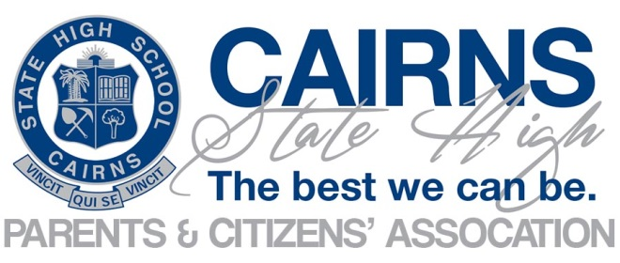
Minutes of General Meeting
Tuesday 21 November 2023
Meeting Commenced @ 1733
Apologies : Brendan Begley, Anthony Easton, Glen Burnett, Lauren Bruce, Marty Long, Karen Freilingsdorf
Attendees:
Chris Zilm  (Principal) | Jules Steer  (P&C President) | Carolyn Green  (P&C Secretary) | Clio Carney | Jaimie Cornford | Jeff Bruce
Kate Coates | Nathan Lee Long

Jules opened the meeting at 5.33pm with the Acknowledgement of Country.
- Confirmation of minutes of previous meeting – 17 October 2023
Jules asked for confirmation of minutes from previous meeting.
Moved: Chris
Seconded: Julie
Motion Carried
- Business Arising from the minutes:
All actions completed and copy of letter of support for 2024 Cambodia trip provided for meeting records.
- Correspondence:
- New Zealand Ski Trip
- Request for P&C support to the 2024 Ski Trip to New Zealand scheduled for the 2024 September school holidays.
ACTION : Draft letter to be provided to P&C President and Secretary for review and signature.
- Italy Trip
- School re-instating trip to Italy and ask P&C to provide a letter of support.
- Trip will be open to Italian students and other students who are interested.
ACTION: Draft letter to be provided to P&C President and Secretary for review and signature.
President, Jules Steer provided support to both school trips.
- Reports:
Principal Report
- Following the recent Student Opinion Survey, a new toilet policy has been implemented to maximise access to student toilet facilities during the day to promote the health and wellbeing and learning opportunities of all students.
Policy includes:
  - Increased supervision
  - Improved record keeping when a child is released during class time.
  - Decrease exposure to risk.
  - Human Rights considerations.
  - The Stop Drop Go principle has commenced and initial feedback from students and teachers is positive.
ACTION : Principal Zilm to provide Secretary a copy of the new toilet policy and break down of stop drop go protocols and student expectations to Secretary to be filed for reference.
- Principal Zilm has looked at ways to communicate with students and in consultation with 2024 student SRC President and Vice President a new Student Update has been created and circulated with students. The edition included:
2024 Phone Policy
  - Smart Watches are to be on areoplane mode once in school boundary.
  - No phones are allowed on school property. Phones must be off and in bags.
  - No ear buds are allowed once in school boundaries.
Love our Lou’s V 2.0
  - Increased supervision
  - Expectations of Students
  - Students will be logged if they go to toilet during class
  - Vape detectors to be installed. Detectors will also detect marijuana and explosives.
  - CCTV’s to be installed.
  - Should inappropriate behaviours continue, parents will be consulted to ensure there are no health issues.
  - Students to be involved in developing the code of conduct for toilets and changerooms.
Vape Usage
- Further discussions continued on Vape usage and the need to education students on the bigger picture, globally, including big tobacco businesses as students are not discouraged by the health warnings. Need to find new ways to communicate to students. Principal Zilm provided an overview of the Blurred Minds Academy Website that provides a number of tools to assist educating our students. These include, Vaping Workshops and Parent Resources.
Damage and Repairs
- Discussion was held on maintenance issues in the school and timeliness of repairs. Principal Zilm advised the committee that current damage to the school is overwhelming and advised the new toilet policy should reduce these issues.

President Report – Julie Steer
- Provided letter of support for 2024 Cambodia Trip.
School Council Report
- Nil
Treasurer Report – (Jules Steer)
- Operating Account $12,610
- Statement Account $20,319
Music Subcommittee (Kate Coates)
- $9,701.44 total in account
- Junior Music Night raffle raised $500.
- School purchased Crotale Bar for music department.
ACTION : Principal Zilm to provide Secretary with copy of invoice and order for Crotakes Bar to be placed on file.
- General Business
- Nil
- Other Business
- Jaime Cornford raised personal expense for setting up raffle link.
ACTION : President to set up bank transfer to reimburse Jaimie.
- Jaime Cornford returned banner used for the sale of raffle tickets to Principal Zilm.
Date of next general meeting – 20 February 2024 –first meeting will be a meet and greet.
Meeting closed @ 7pm
# | Action | Responsible Person | Status
10 | Draft letter to be provided to P&C President and Secretary to support the 2024 New Zealand Ski Trip. | Jules | Completed
11 | Draft letter to be provided to P&C President and Secretary to support the 2024 Ital Trip. | Chris
12 | Principal Zilm to provide Secretary a copy of the new toilet policy and break down of stop drop go protocols and student expectations to Secretary to be filed for reference. | Chris | Completed
13 | Principal Zilm to provide Secretary with copy of invoice and order for the Crotale bar to be placed on file. | Chris
14 | President to set up bank transfer to reimburse Jaimie for personal expense to set up rafflelink. | Jules | Completed

