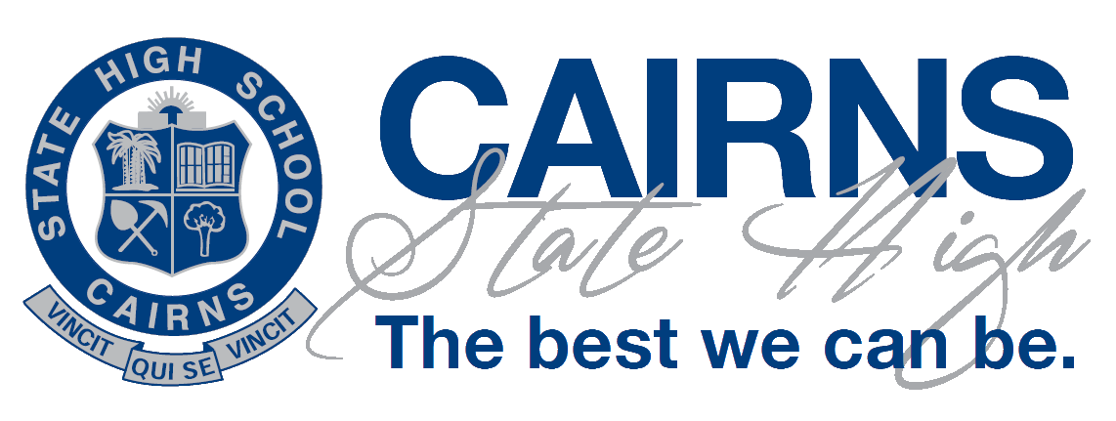 | Senior Schooling:  Key Understandings for Year 11 and Year 12 at Cairns State High School | 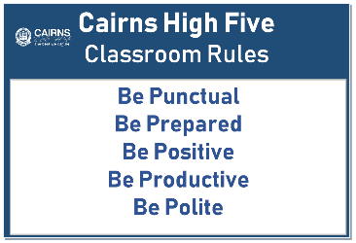
Students engage in their first formal year of Senior in Year 11 and are expected to maintain consistently high standards throughout Year 11 and Year 12 in terms of commitment to study, behaviour and relationship standards.
Processes and support
- Students must complete a ‘Senior Secondary’ Agreement.
Attendance
- All students have their levels of attendance monitored fortnightly.
- Class teachers monitor attendance in lessons
Effort and behaviour
- At the end of Term 1, Unit 1 and then Unit 2, student achievement is reviewed as well as effort and behaviour. Individual plans are then developed for improvement should they be necessary.
- Teachers provide ongoing positive feedback and early intervention notices by Email through the IDAttend system.
Achievement
- Students should view their program as a four Unit program in the subjects they have chosen. As such, subject changes should be rare and cannot be conducted at all after the first two weeks of Unit 1.
- Teachers and HODs of subject areas should be approached as early as possible to assist with resolving issues.
- Students who are experiencing difficulties are encouraged to seek assistance as soon as possible. They should speak with the Head of Senior School, the Head of Department Engagement, Guidance Officer or Head of Department Engagement. A support plan may be developed.
- All students have their QCE plan reviewed at end of Unit 2 and start of Year 12. This process involves the review of effort, behaviour and achievement grades recorded in the report card.
- An ATAR program is for university entry. Students undertaking this program need to commit to genuine study weekly. It is not a back-up plan, rather a serious course of study. ATAR students attaining less than C grades for subject achievement at the end of Semester One may be advised to change subjects and modify their course of study.
- Students are responsible for their decision and engagement in their program of study. The school retains the right to offer alternatives or limited pathways to students not able to meet expectations.
- Students not meeting requirements in Year 11 may be required to repeat Year 11 to better prepare for Year 12.
- All students must complete their education pathway at Cairns State High School with a QCE and a Certificate III VET qualification or an ATAR.
Senior Education and Training Plan (SETP)
This is to certify that the school, parent/s and student have participated in a Senior Education & Training plan interview to discuss career goals and school subjects which will support these goals.
The SETP has been completed and subjects chosen as appropriate to student goals and current academic outcomes.
We also agree to continue to regularly review the SETP during the senior schooling (Year 11 & 12)
Student Name: | Parent/Carer’s name:
Student signature: | Parent/Carer’s signature

Staff Name: | Staff signature:
Date
Senior Secondary Agreement
Expected performance

STUDENT NAME: _____________________________ Connect class: __________

I understand that as a Senior School student, I am of post-compulsory school age, having completed the compulsory phase detailed in the Education (General Provisions) Act Queensland 2006 (Chapter1, Part 5, Section 9).
A young person's compulsory participation phase starts when s/he stops being of compulsory school age (i.e. turns 16 or completes Year 10 whichever comes first) and ends when the person:
- gains a Certificate of Achievement, Senior Statement, Certificate III or Certificate IV or
- has participated in eligible options for 2 years after the person stopped being of compulsory school age or
- turns 17 years of age.
Cancellation of Enrolment for students of post-compulsory school age is based on the legislative framework outlined in Chapter 12, Education (General Provisions) Act 2006 (Qld).
I understand that:
- The enrolment of a student of post-compulsory age will be cancelled if the student’s behaviour amounts to a refusal to participate in the educational program provided at the school. This is evidenced by unexplained absence from school, truancy, non-submission of, or non-participation in, assignments and/or Refusal to complete classwork.
- Behaviour and relationship expectations are provided to me in the school’s Responsible Behaviour Plan for Students (refer to the school website).
I agree to uphold the high standards by meeting expectations set out by the Cairns High Five on every school day:
Be punctual | - Attend all scheduled classes, education programs, assemblies, connect class and any organised activity deemed necessary by the Principal;  - Be on time for all classes and activities;  - Present written documentation for all absences.
Be prepared | - Bring my laptop ready for learning (or access a day loan from the library);  - Have all equipment and supplies needed to engage effectively in learning.
Be positive | - Bring credit to myself and my school in all that I say and do;  - Be a positive role model for all other students;  - Wear the correct school uniform completely and with pride at all times in compliance with the published Uniform Policy. (This includes adherence to Workplace Health and Safety requirements, jewellery, socks, school hat and hair in line with school expectations);  - Develop and use a positive mindset oriented to achieve personal success.
Be productive | - Achieve a Queensland Certificate of Education (QCE) AND obtain and ATAR and/or a Certificate II or III in a vocational education and training pathway;  - Conduct myself in all classes in such a way as to ensure my progress;  - Participate fully in all class learning tasks, e.g, discussions, plans, writing, research, oral reports, performances and assessments,  - Use my laptop in class to complete school tasks only;  - Complete all homework, assignments, exams and other assessment required for valid assessment of the program of study;  - Adhere to the requirements of the school’s Assessment Policy as published on the school website.
Be polite | - Use manners when interacting with all members of the school community.  - Listen actively and speak in turn;  - Use respectful language when speaking with others in class, playground and community;  - Develop productive and positive relationships.
I understand that if I fail to meet these commitments, my enrolment at Cairns State High School may be cancelled.
Student’s Signature: | Parent/Carer Signature:

